Евразийский национальный университет им. Л.Н. Гумилёва

Факультет информационных технологий

Кафедра «Информационные системы»

**ОТЧЕТ**

Студент: Кулахметов Ерасыл

Группа: ИС-23

Руководящий: PhD, Жукабаева Тамара Кокеновна

Астана, 2023

**Introduction**

Creating ‘YerFit’, a fitness-focused application, was a journey that combined creativity, technical skill, and project management. At ‘YerFit’, we redefine fitness convenience. With a single membership, unlock access to every gym in the city. From conceptualizing the company's name and logo to designing a dynamic graphical interface, my goal was to craft a comprehensive fitness platform. This report details the key phases of the project, including design choices, technical aspects, and the overall process.

In the era of rapid technological advancements and the ever-growing importance of health and wellness, the creation of YerFit emerges as a testament to the fusion of innovation and fitness. The journey embarked upon was not merely a development project; it was a vision to revolutionize the fitness industry by making it accessible, engaging, and interconnected.

The genesis of YerFit can be traced back to the inception of a concept, driven by a profound passion for health and a commitment to leveraging technology to enhance individuals' fitness experiences. The goal was clear: to establish a platform that transcends the traditional boundaries of gym memberships and brings fitness enthusiasts together under one digital roof.

**Company Branding and Jira**

The initial steps in the YerFit project involved the meticulous creation of a brand that would embody the spirit of the endeavor. The selection of the name 'YerFit' wasn't arbitrary; it was a deliberate fusion of 'Yer,' representing a sense of ownership and belonging, and 'Fit,' encapsulating the core theme of fitness. This fusion extended into the creation of a visually compelling logo that aimed to evoke a sense of dynamism and vitality.

Efficient project management played a pivotal role. This section outlines the use of Jira for task tracking, issue resolution, and project organization. Jira is a powerful project management tool developed by Atlassian. Jira became the orchestrator of tasks, the resolver of issues, and the guardian of project organization. The details can be seen in image 1.1.



**Image 1.1.** Jira Planning

**Graphical Interface Design**

Employing the robust capabilities of PyQt5 and the user-friendly Qt Designer, the interface was conceived to be not just functional but an immersive experience. This section details the considerations behind UI/UX choices, the significance of each button on the main window, and the seamless navigation between different sections of the application. Each element was thoughtfully placed, ensuring intuitive navigation and a visually engaging layout that would resonate with users of varying fitness backgrounds.

The application's canvas extended beyond the main window, encompassing additional windows that served as portals to distinct facets of YerFit. The "About Us" window became a canvas for narrating the brand's story and mission, while "Filials" unveiled a map of the available gyms, fostering a sense of connection with fitness communities. The "Price" window showcases subscription plans, leading to the "Subscribe" window where users can input their details. The main interface can be seen in image 1.2.



**Image 1.2.** Main Interface

**UML Diagram and Flowchart**

A comprehensive look at the Unified Modeling Language (UML) diagrams created for the YerFit project. These visual representations elucidate the relationships between components, the flow of data, and the intricate architecture that powers YerFit. The UML diagrams became the compass guiding the development process, ensuring cohesion and scalability. The sequence diagram further unfurls the dynamic interactions between different components during user interactions. It offers a chronological depiction of how the user's actions trigger responses within the system. The UML is provided in image 1.3.

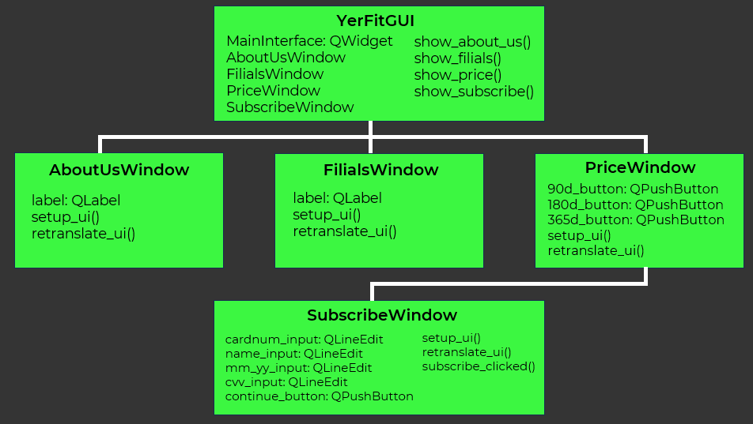**Image 1.3.** UML Diagram

An intricate flowchart elucidates the sequential progression of the YerFit application. This section dissects the decision-making processes and user interactions, offering clarity on the application's workflow. Decision nodes and information flow were meticulously detailed, providing a comprehensive view of the application's dynamic and user-centric workflow. The is Flowchart Diagram provided in image 1.4.

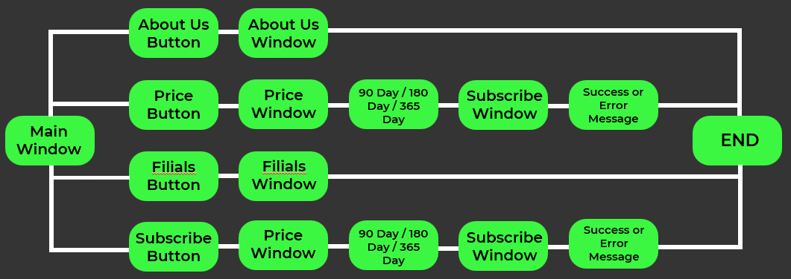

**Image 1.4.** Flowchart Diagram

**Presentation Development**

A detailed overview of the presentation crafted to encapsulate the YerFit project's journey. Crafting a presentation about YerFit involves weaving a narrative that encapsulates the essence of the project. This segment explores the strategic arrangement of information within the presentation, ensuring a storytelling format that engages and informs. From the company's mission to the graphical interface, each slide contributes to the comprehensive narrative, offering a captivating glimpse into the world of YerFit. This segment offers insights into the strategic placement of information, ensuring that the presentation resonates with its diverse audience.

The YerFit project is not just a confluence of code; it is a story told through diagrams, workflows, and collaborative tools, creating a narrative that resonates with developers, fitness enthusiasts, and stakeholders alike.

**GitHub Repository**

The GitHub repository stands as the digital nucleus of collaboration, version control, and codebase management. GitHub ensures the seamless integration of contributions from various developers, offering a centralized platform for collaboration. From code reviews to issue tracking, the repository embodies transparency, accountability, and the ethos of open-source development.

**Conclusion**

The YerFit project reflects a harmonious blend of creativity and technical expertise, culminating in a fitness application designed to empower users on their wellness journey. The strategic use of tools like PyQt5 and Qt Designer, coupled with effective project management through Jira, ensured the successful realization of the YerFit vision. This project stands as a testament to the integration of design and technology in creating a user-centric fitness platform. I have uploaded all of the project's content to GitHub.